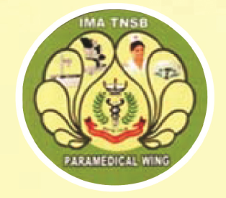 **IMA TNSB PARAMEDICAL WING**

IMA TN State HQs. Building, Doctor Colony,

Bharathi Nagar 1st Main Road, Tambaram West, Chennai- 600 045

**Mobile:** 9078180123 **e-mail:** paramedicalwingimatnsb21@gmail.com

**PRACTICAL EXTERNAL- FOR 75 MARKS**

|  |  |
| --- | --- |
| **Paramedical Institute** |  |
| **Course** |  |
| **Hall Ticket No.** |  |
| **Name of the Student** |  |
| **Viva-20** |  |
| **Practical-30** |  |
| **Log Book-10** |  |
| **Record-15** |  |
| **Total-75** |  |
| **Remarks** |  |

**Date:**

**External Examiner Name: Signature:**